Demythologizing Volatility Drag
June 30th, 2021
Vance Harwood
vh2solutions@gmail.com
970-481-7426
2143 Indian Paintbrush Way
Erie, CO 80516
USA
Vance Harwood is President of Six Figure Investing and a Senior Consultant for Invest in Vol.

Abstract
Many financial advisors claim that volatility inherently drags down the value of unleveraged portfolios. Using historical data, this article disproves the assertion that the difference between arithmetic returns and geometric returns of a price series quantifies volatility drag. It also disproves the claim that volatility drag occurs because recovering from a price drawdown requires a higher percentage move up than down. Characteristics of securities with volatility drag are shown to be inconsistent with economics-based pricing and the Black & Scholes option pricing model. Changes in investment strategies resulting from the invalidation of volatility drag as a loss mechanism are discussed.
Keywords
volatility drag, variance drain, volatility tax, low volatility investing, geometric returns, expected returns

Volatility drag, sometimes called variance drain or a volatility tax, is an effect that is almost universally accepted in the world of finance. Simply stated, it predicts that volatility, the noisy up and down moves of a security, inevitably results in a loss of value. The predicted drag increases rapidly with increased volatility, so investors are advised to minimize it whenever possible. Not surprisingly, “low volatility” products have been developed to take advantage of this effect. They’ve been very successful, gathering over $40 billion in assets.
However, the case for volatility drag rests on shaky foundations. In his book “The Black Swan,” Nassim Talab proposes a class of reasoning errors he calls “ludic fallacies” that err by “basing studies of chance on the narrow world of games and dice.” It’s likely one of the key points used to assert the existence of volatility drag in securities markets suffers from such an underlying ludic fallacy.
As might be expected, the difficulties with volatility drag are subtle. The following illustration identifies two of the key problems associated with the model typically used to demonstrate the existence of volatility drag in securities.
An Illustration: A Volatile Bank Account
A bank wants to liven up its product offerings. Instead of free prizes, the bank offers a “coin toss” account where your account, in addition to receiving its regular, compounded daily interest rate, also participates in a daily event where your account is boosted or reduced by 0.1%, based on a coin flip by a randomly selected customer in the lobby. If the coin lands “heads” then “coin toss” accounts gain a tenth of a percent, and if it lands “tails” your balance is reduced by a tenth of a percent. Assuming a fair coin, the cumulative number of heads vs. tails will be approximately equal over the long run.
The bank states that customers that hold the account over the long term should receive essentially the regular interest rate return, and the bank verified that the long-term arithmetic average of returns (also called the expected value) of these accounts would match the compounded value of the regular daily rate.
Of course, if there’s a run of “heads” the customers’ balances might be considerably ahead of the standard interest rate pace. The bank offers a free transfer of your balance to a regular saving account with no penalties if the customer wishes to “cash out.” The bank’s marketing department expects that the excitement generated by the coin flip accounts will generate an influx of customers that will more than compensate for any losses from winning customers transferring out.

But, the Game is Rigged!
A customer evaluates the mechanics of the process and complains that the bank has an edge with the coin toss accounts. The process that the bank is using is rigged: over time the customers will almost always end up with an effective interest rate lower than the regular interest rate.
The customer’s analysis, first ignoring the regular compounded interest, shows that the account has a “heads I win, tails you lose” characteristic.
- If the sequence of tosses results in heads followed by tails (HT) the result will be 1.001*0.999 = 0.9999990
- If the sequence of tosses is tails followed by heads (TH) the result is 0.999*1.001 which also equals 0.9999990.
In both cases, the customer is slightly behind. Including the regular interest in the analysis doesn’t help; the customer is still slightly behind the regular interest rate in both the HT & TH cases. Of course, many other sequences of heads and tails are possible, but a Monte Carlo simulation shows that in the general case the average loss per toss is consistent.
Fixing The Problem
Embarrassed, the bank agrees to change the process such that neither the customer nor the bank will have an edge. Assuming a fair coin, what value should be associated with heads, and what value with tails to make this a “lossless” process? Amita in the bank’s actuarial department comes up with an answer. A suitable value for the head side is 1.001 and for the tail side, its reciprocal, approximately 0.999000999001. With this approach, the multiplications for the heads and tails cancel each other out over time, making the process volatility neutral. On average the account will compound at the daily interest rate.
While Amita was working on this problem, she discovered another solution. Instead of changing the head and tail values, the problem can be addressed by boosting the effective daily interest rate by the variance divided by two, which in this case is $\frac{{0.001}^{2}}{2}$. With this approach, the losses due to the coin toss process are precisely compensated for by boosting the effective interest rate. Amita considers this solution a hack because it doesn’t address the core issue—the fundamentally lossy process associated with the coin toss. An analogy would be having a home furnace thermostat consistently turns off two degrees lower than it should and “fixing” the problem by telling everyone to set the thermostat two degrees higher.

Lossy Processes and Lousy Metrics
The bank story identifies two issues. One, the multiplication of symmetric percentage moves creates an inherently lossy process. The second is that a standard metric, the arithmetic mean/expected value when used with multiplicative processes over-promises. The expected value on the bank’s original process was the daily interest rate, suggesting a fair process, but in reality, the process favored the bank.
Arithmetic means when calculated using data from multiplicative processes are order sensitive, unlike additive processes, e.g., determining the average height of a population, where the order of calculation doesn’t change the arithmetic mean. Consider two price sequences, where the final price is the same, but the order of the second and third prices are reversed.
Sequence A: 100, 101, 104, 103, 100
Sequence B: 100, 104, 101, 103, 100
For multiplicative processes the formula for computing the arithmetic return when the probabilities for each period are the same is $\frac{1}{N}\sum_{i=1}^{N}{\frac{P_{i}}{P_{i-1}}-1}$, where N equals the number of periods and $P_{i}$is the i^{th} price.
The arithmetic return for these sequences is path-dependent—the final result is always a function of the volatility of the intermediate sequence. For example, the arithmetic return of sequence A is lower than sequence B’s by almost a factor of two (~0.00240 vs ~0.00457).
When used in a multiplicative domain the arithmetic average increases with the volatility of the sequence. Since there’s no such thing as negative volatility, the arithmetic return/expected value of a multiplicative process with non-zero volatility will always be higher than the geometric return, and the probability of the final return exceeding the expected value will always be lower than 0.5 probability (Grandville 1998; Hughson 2006).
In multiplicative environments, the geometric return is the superior metric, being insensitive to the order and volatility of the data.

In the Long Run the Expected Value is a Gamble, not a Forecast
Over short periods of time the differences between expected and geometric returns are small, but over time the differences become dramatic. In the article “The volatility paradox: When winners lose and losers win,” the authors propose a thought experiment where a portfolio’s annual returns have an equal chance of being either plus 20%, or minus 18% (Collie 2017). The long-term arithmetic returns of this experiment will average 1% annually, but the realized returns average minus 0.8%. The author describe this discrepancy as a paradox, but it only appears to be a paradox because of their erroneous view that the arithmetic return/expected returns is a reliable forecast of future value rather than a volatility boosted metric.
Figure 1 shows the result of a Monte Carlo simulation (2.4 million runs) of this experiment, going out a thousand years with the portfolio value starting at $100.
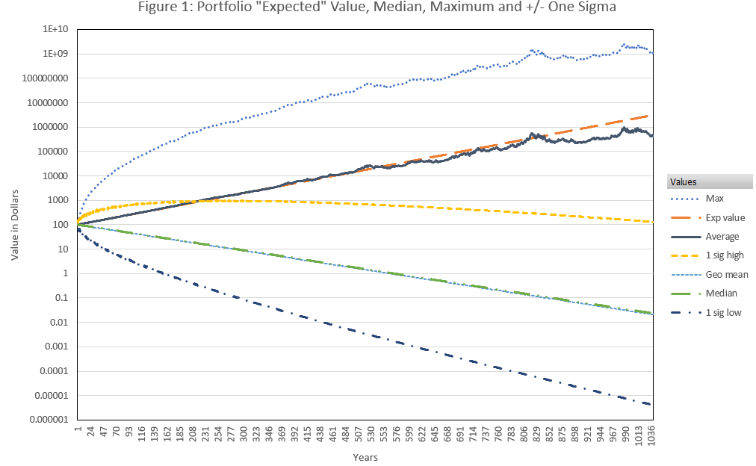
The so-called expected value does increase at around the 1% rate but the probability of reaching or exceeding that value has dropped below 0.2% at the 1000-year mark. In contrast, the predicted geometric mean and median of the actual results are indistinguishable. The 1000-year example magnifies the effect but even for a 30-year horizon, the even-odds return is 58% lower than the expected return, more than enough shortfall to derail a retirement strategy.
Figure 1 shows various statistical metrics but doesn’t illustrate the highly non-linear way that the prices themselves are distributed. The maximum and expected values become noisy in the longer time frames because there aren’t many data points to average in the high price ranges. Figure 2 shows how the simulated portfolio values at the 1000-year point are distributed relative to each other.
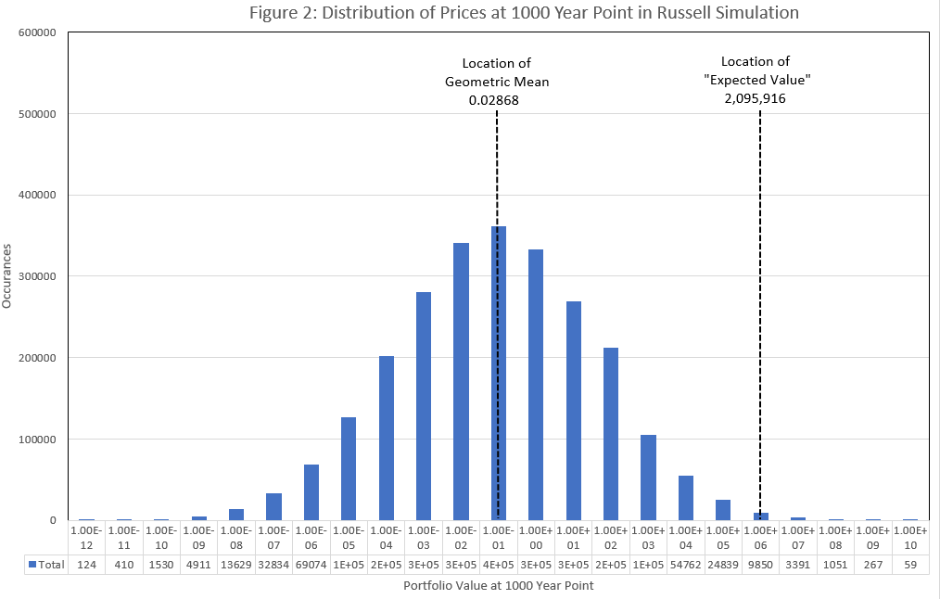
Over time this distribution, effectively the density of prices, becomes log-normally distributed, ranging over multiple orders of magnitude—something we don’t encounter often in our daily lives. In these situations, arithmetic averages lead us astray, a few prices are so high that they drag the average price well above the median price.
An analogous situation would occur if you took a random sampling of annual income from five people and one of them happened to earn over a billion dollars a year. Table 1 shows a possible result.
Table 1
Five Annual Incomes | Average Income
$65,000 | $250,061,000
$85,000
$75,000 | Median Income
$1,500,000,000 | $80,000
$80,000

The average income in table 1 is $250 million, but no one’s actual income is within a factor of 5 of that number. When data is spread out over multiple decades the median, in this case, $80K, is a much better number for forecasting.

Volatility Drag and Real Markets
Twenty-five years ago, Tom Messmore published a paper that analyzed the differences between arithmetic mean (AM) and geometric mean (GM) for multiplicative processes (Messmore 1995). He showed that the difference between these two metrics closely matches the variance divided by two. He then applied this AM-GM relationship to markets, where it is generally accepted that the multiplicative model is appropriate. This relationship requires that the AM and/or the GM vary with volatility, but it was not obvious which metric was affected.
He proposed a thought experiment, essentially identical to the bank’s first proposal except with zero daily interest, modeling market moves as essentially a coin toss, with equal and opposite percentage face values. The arithmetic return of this experiment is zero and the geometric mean is less than zero. Messmore mistakenly assumed that the arithmetic return/expected value is a reliable, even-odds forecast of future value, so he interpreted the negative value of the geometric mean as proof that geometric returns are eroded by volatility.
Messmore’s AM-GM relationship is $R_{a}^{ }- R_{g }^{ }≈ \frac{σ^{2}}{2}$ (1)
Where:
- $R_{a}^{ }$= arithmetic mean return
- $R_{g}=$compound return or the discrete geometric mean return
- $σ$ = volatility, $σ^{2}$ is variance.
Messmore claimed that the term on the right side of this equation, the variance divided by two, quantified “Variance Drain,” an effect that erodes economic returns. Messmore’s variance drain concept was broadly accepted, and it is assumed in most financial analyses of securities markets.

How Do Markets Work Anyway?
Messmore modeled volatility in securities markets as having casino-style attributes, even-odds for symmetric percentage moves, which inherently has volatility drag. Does that model realistically represent the real world or is it a ludic fallacy, based on an overly simplistic game?
Securities markets are complex, ultimately human-driven processes, unconstrained by the laws of physics. Typically structured as double-sided auctions, market participants usually include buyers, sellers, market makers, and high-frequency traders. Arbitrageurs stand ready to profit from any actionable differences between related markets (e.g., SPX futures vs S&P 500 Exchange-Traded Funds).
Another model for markets is that they are estimators of value where the effects of noise-like volatility cancel out over time. The difficulty of estimating value varies tremendously, ranging from straightforward present value calculations (e.g., a USA Treasury note), to valuing a corporate start-up losing billions of dollars a year. An incredible amount of effort, fueled by fear and greed, goes into determining the “right” price for securities.
A value-driven market would not be constrained by previous values or past volatility in determining what the best guesses are for the present value (exceptions being short term measures like futures limit up/down, trading halts, or regulated markets). Of course, historical patterns might be included via factors such as momentum, but historic information will likely be interpreted differently by the various market participants.
All markets have volatility, but does volatility inherently erode prices? Or is volatility essentially noise, obscuring the signal (current value)—often annoying, sometimes scary, but ultimately not changing the signal?
Characteristics of a Volatility Neutral Model
Analytically, modeling a market that’s value-estimating and treats volatility as noise is straightforward. The reciprocal approach proposed by Amita in the bank example can be generalized with exponential compensation to the signal and noise which over time cancels out noise while preserving the signal.
A characteristic of exponentially compensated volatility is that equally likely positive and negative moves have different absolute values. In contrast, coin flip style market models assume equally likely positive/negative percentage moves will have the same absolute value.
It’s counterintuitive that volatility we encounter in the real world would have unequal percentages that cancel out, but it’s inherent in the mathematics of quantity and proportionality. An apple vendor that sells 4 apples out of their 20-apple inventory sees a 20% drop in their inventory. Buying four apples from their wholesaler to replace them results in an inventory increase, of 25%, from 16 to 20.

A Quantitative Model of a Volatility Neutral Market
Volatility-neutrality is an inherent aspect of Geometric Brownian Motion (GBM), a process that is generally agreed to be a good basic model for how securities markets work and a foundational assumption of the Black and Scholes model for option pricing (Sigman 2006).
A discrete-time solution to the GBM stochastic differential equation says that for one time period to the next a market’s prices can be modeled by:
$P_{i}^{ }= P_{i-1}^{ } e^{R_{gc} + σ_{c}z}$ (Sundaram 2011, part 6)
- $P_{i}^{ }$ = price at the end of period “i”
- $R_{gc}$ = drift factor, continuously compounded geometric returns
- $σ_{c}$ = standard deviation of log returns
- $z$= a Wiener process, $z \sim η\left(0,1\right) the standard normal distribution$
The exponential function in this equation has the effect of converting normally distributed volatility moves that are symmetric around the drift term into “log” versions of themselves. This exponentially compensated behavior has the same volatility-neutral characteristics as Amita’s preferred solution to the bank’s coin toss problem.
Most attributes of this model are a good match with historic market characteristics:
- The long-term average volatility tends to be stable regardless of price
- Long term prices and returns are inherently log-normally distributed
- Prices have a low side limit, usually zero, that’s consistent with the limited liability attribute of stocks. However, the model can be adapted to allow bounded negative prices (e.g., futures contracts with required physical delivery).
As with most models, this one does not capture all the nuances of the physical process being modeled. For example, it significantly underestimates the probability of higher sigma events in markets. This weakness in the model could be improved upon by replacing the Gaussian distribution used to model volatility with a symmetric process with fatter tails such as the Laplace distribution.

Arguments for Volatility Drag
The arguments typically used to assert the presence of volatility drag in unleveraged securities are:
- A sequence of symmetric plus/minus percentage moves in a market creates an ongoing drag on prices
- The difference between the arithmetic mean and geometric mean in a price history quantifies volatility drag (Spitznagel 2018)
- It’s harder for markets to recover back to previous levels because the percentage gain required to recover is larger than the percentage loss (e.g., a 20% drawdown requires a 25% recovery to regain the pre-drawdown price).
The first argument is an assumption, based on intuition, that may or may not be how markets work. Any “proof” of volatility drag that assumes an inherently lossy underlying process proves nothing more than the model itself is lossy; it proves nothing about markets.
The second and third arguments are easier to disprove.

Falsifying the AM/GM Difference as an Estimate of Volatility Drag
The claim that the difference between AM and GM quantifies volatility drag can be tested by comparing its predictions with historic results of securities with well-established volatility drag characteristics, specifically resetting leveraged exchange traded products (ETPs
Periodically resetting leveraged ETPs seek to deliver a percentage move that is a multiple (positive or negative) of an underlying security’s percentage move. For example, a daily resetting 2X leveraged fund will target a daily increase of 6% if its underlying index goes up 3% on that day. To achieve this performance, the effective investment level in the underlying must be rebalanced during each measurement period to maintain the leverage factor for the next period. One side effect of these asset shifts is a well-characterized drag on their prices due to volatility that is a function of the leverage factor (Crouse 2019).
The approximate equation for computing the average per period volatility drag on the geometric returns for these products is:
$R_{vd}$ = $L\left(L-1\right)\frac{{σ_{u}}^{2}}{2}$ (2)
Where:
- $R_{vd}$ = reduction in the per period geometric returns due to volatility
- L = leverage factor, which can be positive or negative. Negative factors are used with inverse funds.
- $σ_{u}$ = volatility of the underlying index
One of the characteristics of this equation is that it predicts an asymmetry in volatility drag between positive and negative leverage levels. For example, it predicts that the average per period volatility drag of -1X leveraged and +2X leveraged products will both be ${σ_{u}}^{2}$, even though the -1X product only has half the volatility.
The historic volatility drag can be calculated by subtracting the actual returns of the leveraged funds from the appropriately leveraged historic returns of their underlying index. The equation used to compute the volatility drag is $R_{vd}$ = $L\left({Index}_{g_{u}}\right)$ –$R_{gl}$
Where:
- $R_{gl}$= geometric returns of the leveraged security
- ${Index}_{g_{u}}$= geometric returns of the underlying index
Figure 3 shows the predicted average daily volatility drag levels using the AM-GM difference and equation (2) methods compared to the measured drag on -2X, -1X, +2X, and +3X leveraged S&P 500 ETPs for June 2009 through 2020, when the average daily S&P 500 index (SPX) volatility was 1.1 percent.

Figure 3: Volatility drag predictions used simulated leveraged fund with P_{n} =P_{n-1} *(1-fees+dividend + L*(SPX_{n}/SPX_{n-1}-1))
The predictions of equation (2) closely match the actual results shown in figure 3, whereas the AM-GM predictions differ dramatically from the measured volatility drag and do not exhibit the asymmetric aspect of volatility drag associated with positive and negative leverage. In the case of resetting leveraged securities at least, the AM-GM relationship does not correctly predict volatility drag.

The AM-GM Difference Quantifies Volatility, Not Volatility Drag
Rather than predicting volatility drag, the difference between the arithmetic return of a multiplicative series and its geometric mean is an estimate of the variance divided by two. Solving for volatility in equation (1) gives the following equation:
$σ ≈ {\sqrt{2\left(R_{a}^{ }-R_{g }^{ }\right)}}_{ }^{ }$ (3)
Figure 4 compares the result of using this AM-GM based calculation of estimated volatility vs the standard deviation of log returns for the S&P 500 index and associated leveraged funds from 2006 through 2020.
The AM-GM based volatility estimates shown in figure 4 closely match the results of the standard deviation calculation. Rather than estimating volatility drag, the AM-GM difference for multiplicative processes is a thinly disguised way to estimate volatility. It was just an unfortunate coincidence that the variance divided by two approximation that Messmore determined to be the difference between the AM and GM of a multiplicative series happened to match the volatility drag of his coin toss model of the market.
Do the Unequal Percentage Moves Required For Price Recovery Cause Volatility Drag?
As mentioned earlier, one argument used to support volatility drag is that it seems harder for markets to recover back to previous levels after a big downturn (Spitznagel 2018). For example, a 20% downturn requires a 25% increase to get back to the starting level, worse yet a 50% downturn requires a 100% move to recover.
It’s certainly critical that investors avoid big losses, for example from new exciting businesses failing or speculative bubbles busting. If investors are not well-diversified, drawdowns from these high-risk bets can result in drastic losses to their portfolios. Big losses may be very difficult to recover from if driven by events with persistent economic impact, for example, big, unexpected operating losses, lawsuits, product failures, or loss of key personnel. However, many significant market downswings are not driven by long-lasting real-world failures. For example, macro-economic cycles such as the Great Financial Crisis of 2008/2009 and the Coronavirus Crash of 2020 exhibited dramatic downturns, but then had rapid recoveries. During the Coronavirus Crash in February/March 2020, the S&P 500 dropped 30% from its January 1, 2020 price, but finished 2020 with an overall gain of 16%. Even 1987 ended up 2% for the year despite a 20+ sigma crash on October 19th.
The linkage of the price of a security with its underlying capability/economic value is tenuous. Unlike a physical factor such as population or factory capacity, a price may vary dramatically without necessarily reflecting an actual change in capability or profitability. If a company’s factory burns down, its capability has been substantively reduced, however, if its market cap drops $100 million because the CFO just announced they are leaving the company, its value may recover significantly quicker—perhaps during the next news cycle.
If it is indeed harder, as volatility drag proponents say, to recover from downswings just because a larger percentage move up is always required, then we should see that pattern in historic data. For example, the time required to recover after a 3-sigma downturn in price should be longer, on average, to revert to the pre-event level than the reversion time after a 3-sigma positive jump. Figure 5 shows S&P 500 index reversion times back to the pre-event level for the 77 positive and 133 negative events of magnitude three sigma, or larger between 1960 and 2020.
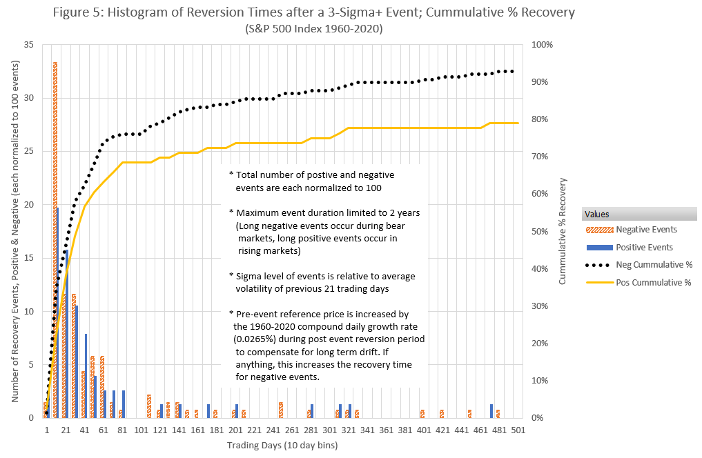
The historic data does not support the prediction that the time required until prices revert to their pre-event levels after big moves should be longer for big negative events. Sixty years of data indicate the opposite, the S&P 500 reverts faster after negative events than it does for positive. This result falsifies the assertion that volatility drag impedes price recovery after drawdowns.
When Volatility Drag Look Like When it is Present?
Before going into additional arguments regarding the existence of volatility drag in regular investments it may be instructive to review the characteristics of securities that do have volatility drag.
Securities with intrinsic volatility drag have the following characteristics:
- An inevitable, ongoing drag on price
- The price of the security cannot be established without knowing a previous price and the subsequent volatility of the security
Since volatility is ever-present in active markets, any security with volatility drag will have an inexorable eroding force acting on it. Of course, there might be positive drift factors that are large enough to overcome the volatility drag, but in practice, the drag factors are often high enough that they have a significant impact on the security’s long-term performance. A straightforward way to observe the impact of volatility drag is to compare the performance of a resetting leveraged fund vs its underlying index. Figure 6 shows two instances where the S&P 500 revisited the same level months later but the 2X leveraged version of the S&P 500 lagged. Portfolio values start at one thousand dollars (A/B 31-July-2017 & C/D 18-Feb-2020) and the portfolios each hold just the equivalent of the S&P 500 or the 2X fund.
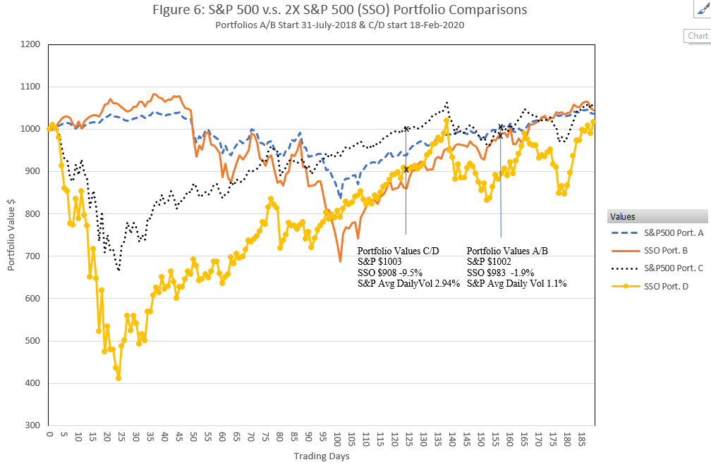
The S&P 500 returned to the starting level 145 trading days later for the A/B portfolios and 123 days later for the C/D portfolios. The 2X fund traded at lower levels each time the S&P 500 returned to its starting level, mostly due to volatility drag (fees were an additional factor).
The volatility drag losses occurring in a 2X leveraged fund are only a factor of two larger than the losses that volatility drag proponents claim to exist on regular securities. If true, that means that in the period between February and August 2020 around $1.25 trillion was lost via volatility drag from the S&P 500’s then $25 trillion market capitalization—which seems unlikely.
Pricing a Security with Volatility Drag Requires Historical Information
The price of a market traded product or security can usually be estimated based on its current attributes, be it cost of production, scarcity, required profit levels, interest rates, future potential, net earnings, or some other basis. The precision of that price estimate depends on the nature of the security (for example the present value of a bond is precisely related to its interest rate and payout characteristics). But there’s no way to accurately price a security that has volatility drag without having a price starting point (e.g., the inception price of the product) and knowing the subsequent price history/volatility. For example, if the price of a daily resetting 2X leveraged fund and its underlying were priced at $100 and $50 respectively 200 days ago and the price for the underlying is now $60 we can only say that the 2X’s price will be somewhere between zero and $144 depending on the intervening volatility.
The Case for Volatility Neutral Markets
Unlike resetting leveraged ETPs, we lack a precise objective reference to determine if regular securities have inherent volatility drag. Instead, we must rely on subtler arguments to determine if securities markets are better described as having volatility drag or being volatility neutral. The existence of volatility drag in regular markets is in conflict with these three observations:
- Markets don’t behave like they have volatility drag
- There are no theoretical underpinnings for volatility drag in general markets
- The Black & Scholes option pricing model will misprice options if volatility drag exists in the underlying security.
On the first point, if volatility drag does exist in securities markets it is an aberration amongst markets in general. We don’t see evidence of long-term, volatility-driven declines in markets like bread, gold, or bonds. We certainly don’t assume that prices in these markets will inevitably be eroded due to volatility.
Unlike compulsive gamblers, the net worth of the long-term investor, especially one holding broad-based equity indexes tends to climb quite nicely over time. Finally, it seems absurd that a stock tied to a real-life company cannot be valued on its merits without being structurally dependent on past prices/volatility—which is required in a market with volatility drag,
On the second point, there is no theoretical framework that supports the assertion that markets have volatility drag. The model commonly proposed, based on “coin flip” style symmetric moves, does have volatility drag, but it’s a hypothesis without historical evidence or a theoretical foundation. A volatility neutral model on the other hand is based on the generally accepted Geometric Brownian Motion stochastic differential equations that have been verified as providing a good first approximation to market behaviors.
Regarding the third point, the Black & Scholes (B&S) option pricing model includes as one of its building blocks the GBM style model for securities prices, which does not include any provision for volatility drag. The B&S model is far from perfect, e.g., it does not predict that options will tend to have different implied volatilities depending on strike and expiration, but nonetheless, it is widely considered a good first approximation for pricing options.
Because the standard B&S model does not incorporate volatility drag, it will misprice options on securities that do have volatility drag such as resetting leveraged ETPs. Call options for both positively and negatively leveraged products would be overpriced by the B&S model because the ETP’s prices at expiration for each are eroded by volatility and the model does not account for that. Call options on a resetting leveraged ETP will on average, expire worthless more often than the equivalent option on a volatility drag-free security with the same realized volatility as the leveraged product. Figure 7 shows simulation results that support that hypothesis. The results in figure 7 also demonstrate that adding an upfront supplemental positive drift factor calculated to compensate for the volatility drag on a 3X fund brings the statistics back in line with a security without volatility drag.
The B&S model is widely used for option price analysis. It seems unlikely that systematic mispricing due to volatility drag in the vast majority of securities would go unnoticed. This is yet another reason to conclude that vocality drag is not present in regular securities.
What Model is Better?
Emanual Derman in “A Stylized History of Quantitative Finance”, states that "There are no reliable theorems in finance; it’s not math, it’s the world" (Derman 2018). All models are imperfect in terms of reflecting reality, but some are more imperfect than others. The volatility drag model for regular markets does not make any successful predictions and is at odds with solutions to GBM stochastic differential equations as well as the Black & Scholes option pricing model.
On the other hand, a volatility neutral model emerges naturally from the assumption that markets represent an estimate of value, and that the noise of volatility does not inherently erode the value of a typical security. It is consistent with the theoretical underpinnings of GBM and correctly predicts that downward moves do not take longer than positive moves to mean revert.
The qualitative and quantitative arguments support a volatility neutral model as a better way to represent securities markets, supporting the conclusion that volatility drag is a ludic fallacy—except for resetting leveraged products.
So What?
What are the implications for investors if volatility drag doesn’t exist for stocks, bonds, and non-leveraged Exchange-Traded Products? It means:
- That popular, “low volatility” products do not have a structural, volatility drag based advantage over portfolios with higher average volatility (e.g., the S&P 500).
- The initial use of margin to boost the leverage on a portfolio does not incur an economic penalty just because leverage increases the effective volatility of a portfolio
- More volatile securities are not handicapped by an erosion factor that increases exponentially with volatility.

On the other hand, recognizing where volatility drag doesn’t exist can make lower volatility securities more attractive. Currently, analysts are faced with a false dilemma, forecast prices using expected values known to be overly optimistic or with geometric returns said to be distorted by volatility drag. Rejecting volatility drag as a real-life mechanism in the general case will highlight the superiority of using geometric returns of securities—as opposed to the volatility boosted expected returns—for forecasting long-term performance.
The absence of volatility drag in individual securities will help clarify the underlying mechanics of strategies that use diversification, leverage, and rebalancing to optimize returns.
Recognizing that markets are better described as value estimators, rather than inherently lossy casino-style games helps us to better model and understand markets. It’s time to recognize that while volatility can have a major impact on prices, it’s not an inherently destructive force.

References
Collie, Bob. 2017. “The volatility paradox: When winners lose and losers win.” Russell Investments. https://russellinvestments.com/-/media/files/us/insights/institutions/defined-benefit/the-volatility-paradox-when-winners-lose-and-losers-win.pdf
Crouse, Matthew. 2019. "Leveraged Investment Products: Monthly Rebalancing Boosts Performance, but Tail Risk Looms." The Journal of Index Investing. Winter 2019, 10 (3): 58–69. doi:10.3905/jii.2019.1.074.
de la Grandville, Olivier. 1998. "The Long-Term Expected Rate of Return: Setting It Right." Financial Analysts Journal 54 no. 6: 75-80. https://doi.org/10.2469/faj.v54.n6.2227.
Derman, Emanuel. 2018. “A Stylized History of Quantitative Finance.” Columbia University. http://emanuelderman.com/wp-content/uploads/2016/11/Stylized-History-Stellenbosch-Derman.pdf
Hughson, Eric N., Michael Stutzer, and Chris Yung. 2006. “The Misuse of Expected Returns.” Financial Analysts Journal 62 (6) (Nov-Dec): 88-96. https://ssrn.com/abstract=953068. http://leeds-faculty.colorado.edu/stutzer/Papers/MisuseOfExpectedReturnsInFAJ.pdf.
Messmore, Thomas E. 1995. “Variance Drain,” The Journal of Portfolio Management 21, no. 4 (Summer):104-110. https://jpm.pm-research.com/content/21/4/104.
Sigman, Karl. 2006. IEOR 4706 at Columbia University.http://www.columbia.edu/~ks20/FE-Notes/4700-07-Notes-GBM.pdf.
Spitznagel, Mark. 2018. “The Volatility Tax.” Universa Investments L.P, 2018. https://www.universa.net/UniversaResearch_SafeHavenPart4_VolatilityTax.pdf.
Sundaram, Rangarajan K. and Das, Sanjiv Ranjan. 2011. Derivatives: Principles and Practice. McGraw-Hill/Irwin. https://b-ok.cc/dl/5472528/1d5c8a.

